CS 255 System Design Document

UML Diagrams

UML Use Case Diagram

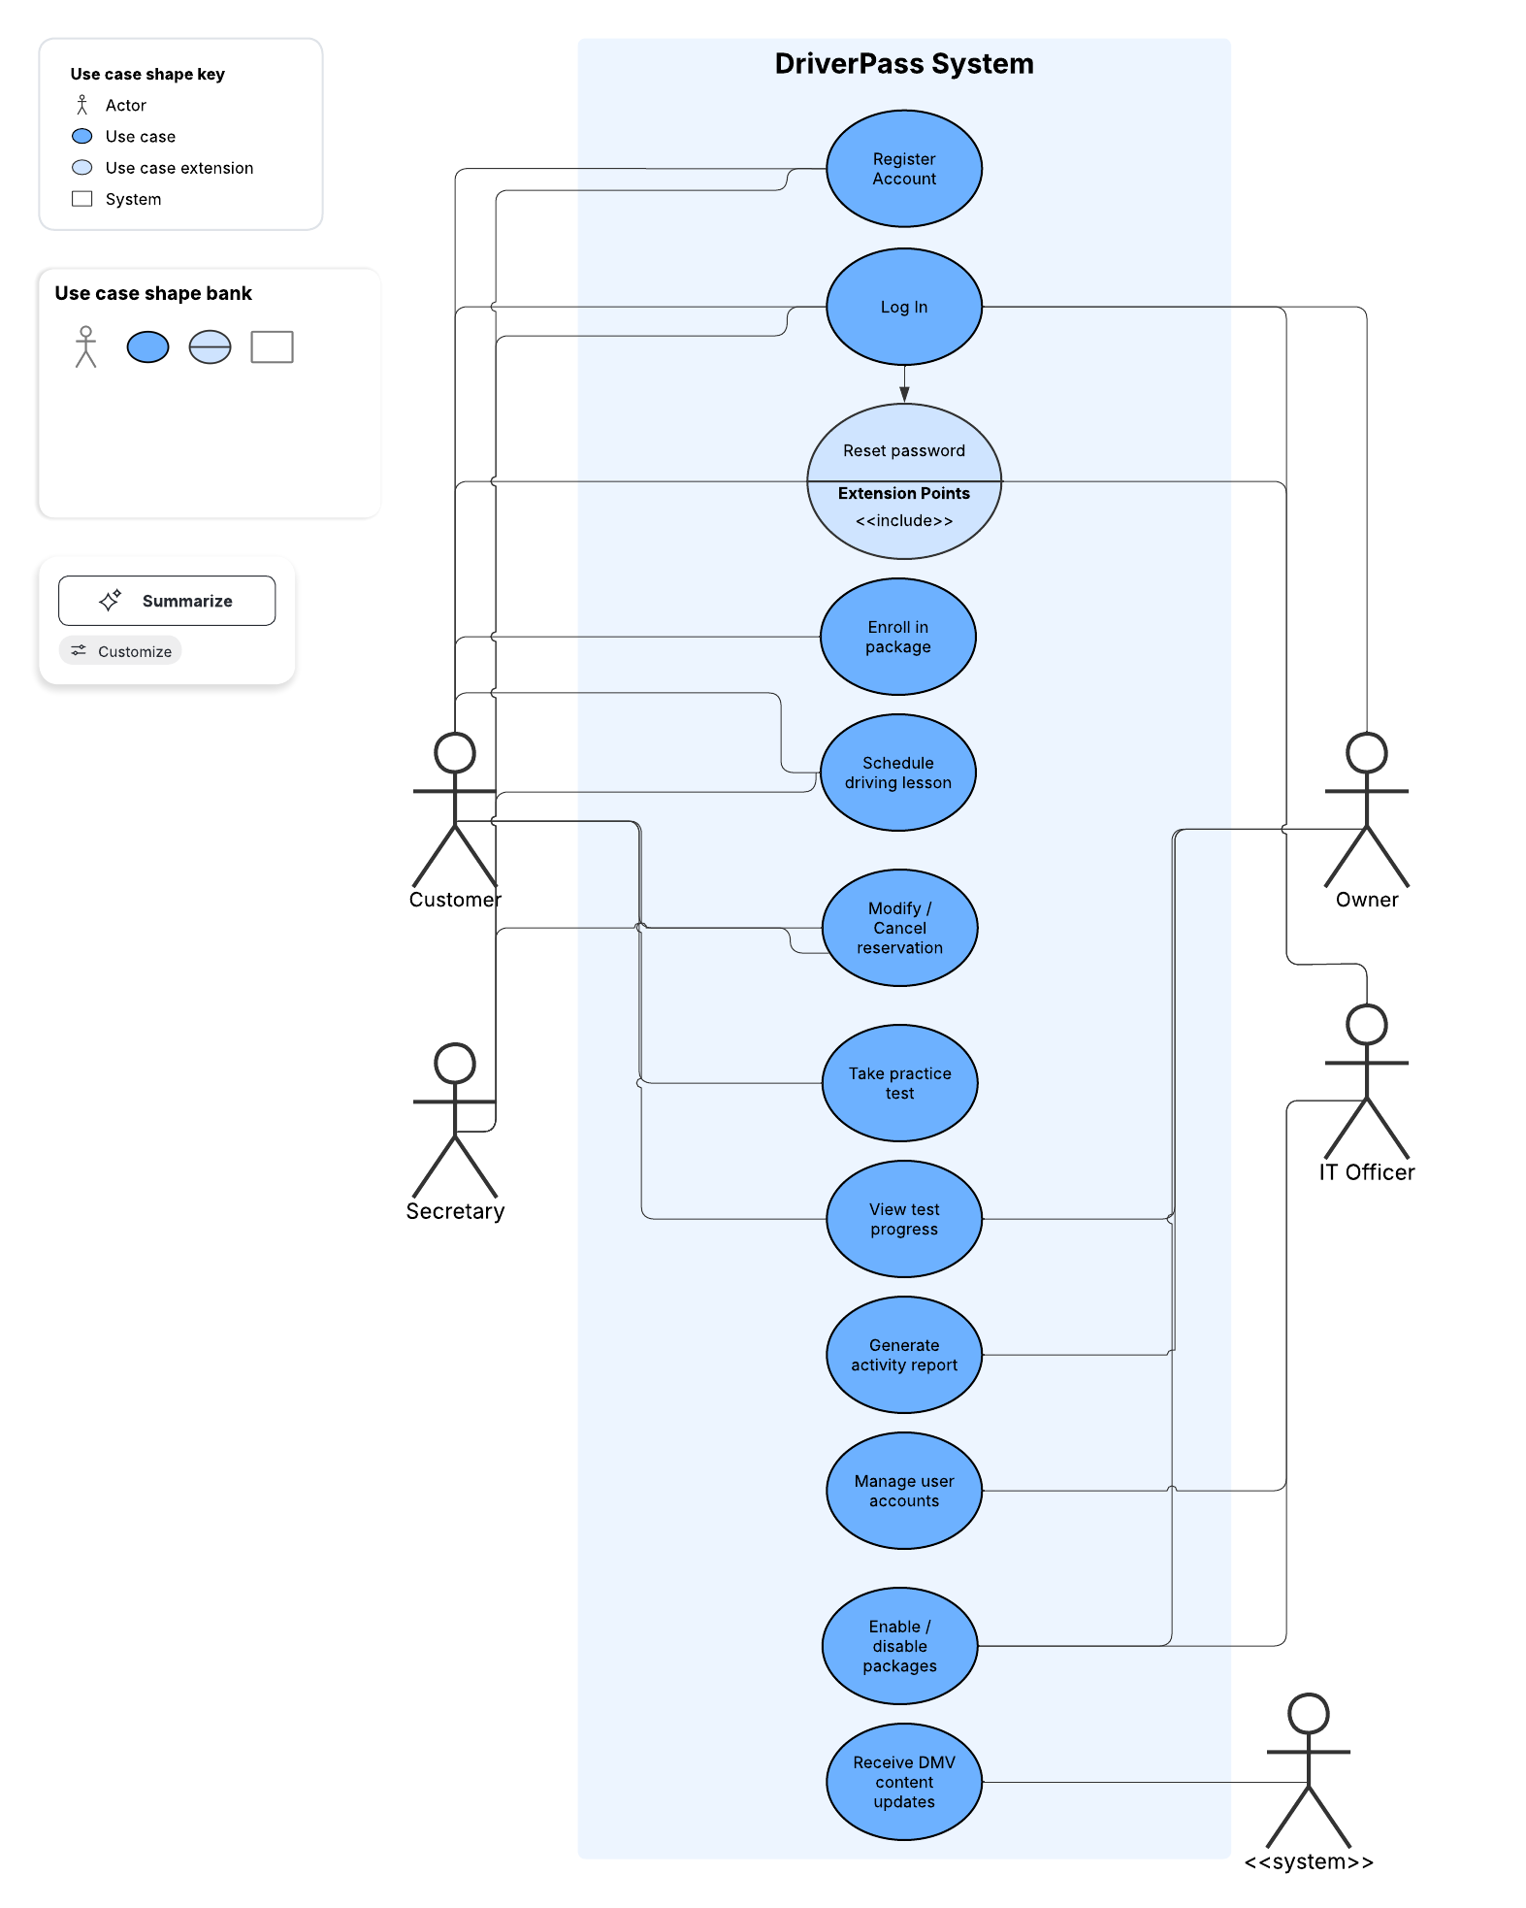

UML Activity Diagrams
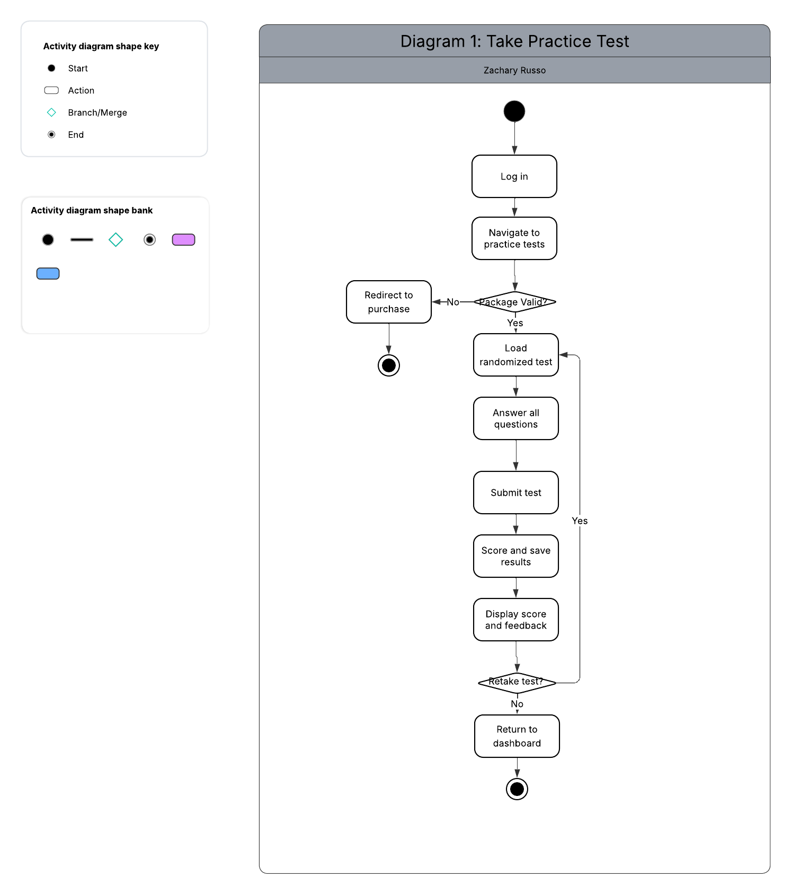
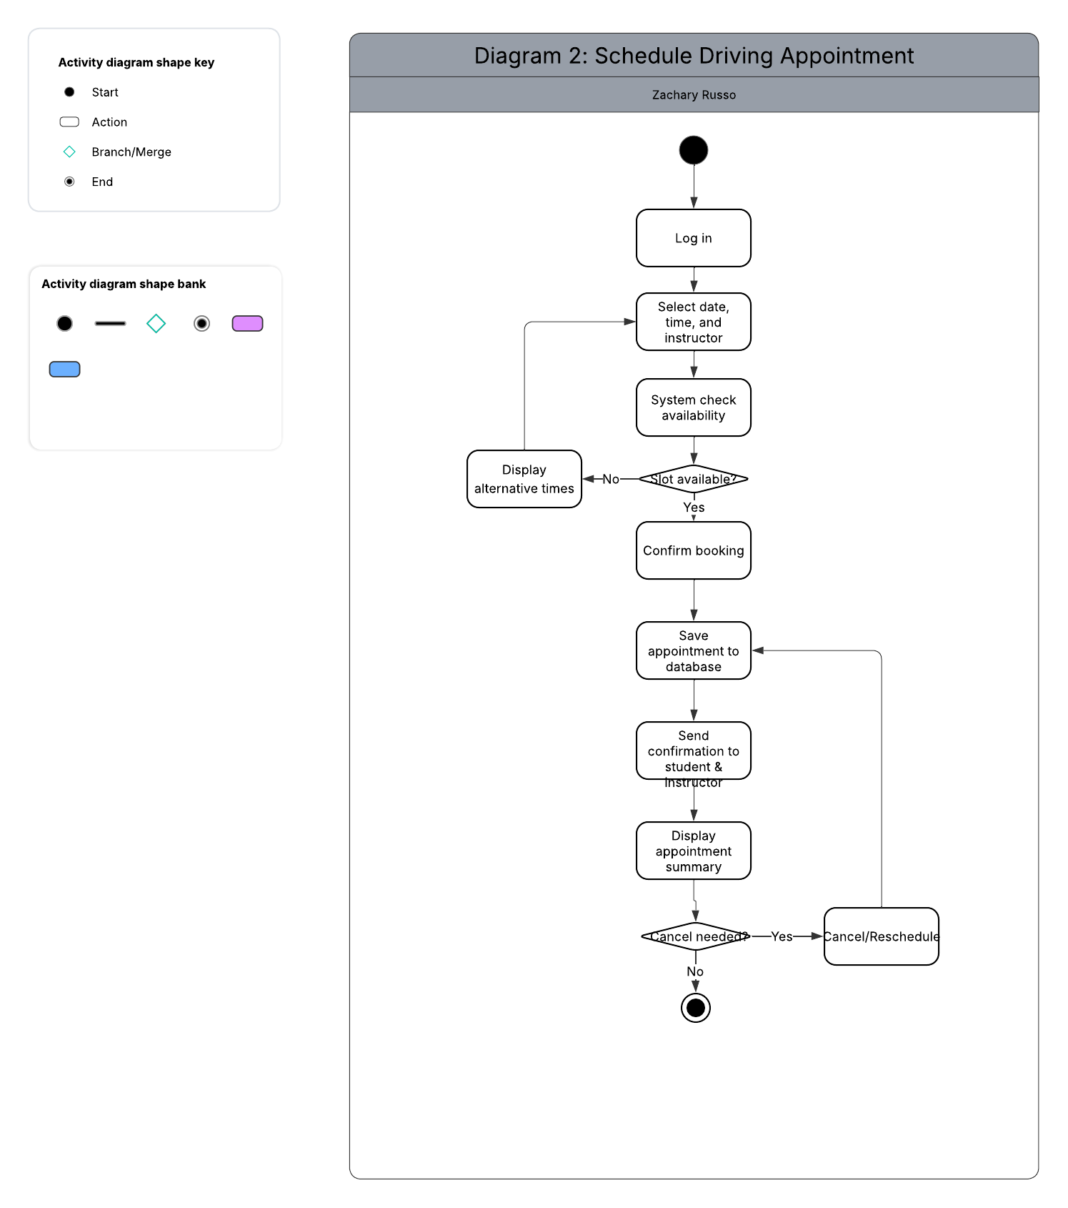

UML Sequence Diagram
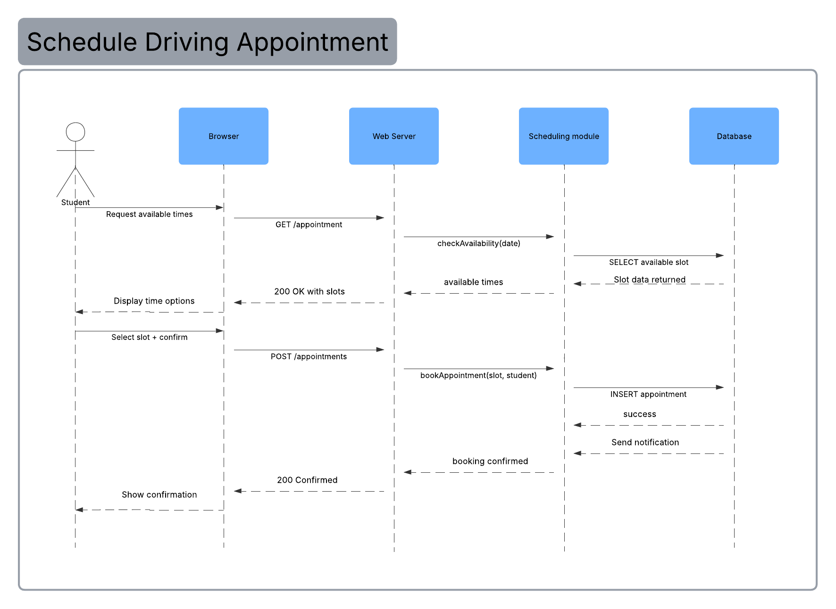

UML Class Diagram
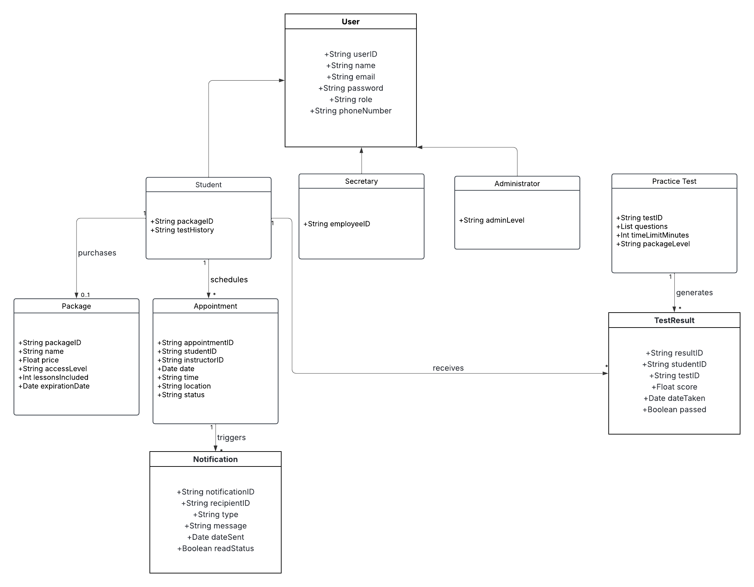

Technical Requirements
Since DriverPass is a cloud-based web app, most of the heavy lifting on the hardware side is handled by the cloud provider. Here’s a breakdown of what the system needs to run properly.

Hardware Requirements
Since the system runs in the cloud, there’s no need for DriverPass to manage their own servers. The cloud provider handles that. Staff will just need a basic computer, a browser, and a decent internet connection. Students can use anything with a browser, whether that’s a laptop, phone, or tablet. Daily backups will be set up through the cloud so no data gets lost.

Software Requirements
The front end will be built with something like React or Angular, and the back end will use Node.js or Spring Boot. For the database, MySQL or PostgreSQL works well here since the data is relational. The system also needs a notification service like Twilio or SendGrid for appointment reminders and confirmations, a scheduling API to handle booking logic, and a simple admin interface so staff can update test content without touching the code. It needs to work on Chrome, Firefox, Safari, and Edge.

Infrastructure Requirements
The system will be hosted on AWS or Azure, which gives us the uptime, scalability, and reliability DriverPass needs. A load balancer keeps traffic spread across servers so nothing crashes during busy periods, and a CDN helps pages load faster for users in different locations. The database will have automatic failover in case something goes wrong. Backups run daily and are kept for 30 days. There will also be a separate staging environment for testing updates before they go live, and all traffic will be encrypted over HTTPS.

Security Tools and Requirements
Each user role (student, secretary, administrator) will only have access to what they actually need, which is handled through role-based access control. Passwords get hashed with bcrypt so they’re never stored in plain text. Sessions time out when inactive. Admin actions are all logged in an audit trail. There’s also a web application firewall at the cloud level to block things like SQL injection and XSS attacks. The DMV connection uses token-based authentication to make sure the data coming in is legit.

